s
Ms Barbara Balke
Secretary General
European Investment Bank
100, Boulevard Konrad Adenauer
L-2950 Luxembourg

Dear Secretary General,

Further to your email dated 2nd of august 2023 and the opinion of non-objection from the Appointment Advisory Committee (AAC), it is my pleasure to confirm that the Government of the Kingdom of Denmark has decided to propose Ms. Vestager for appointment to the position of President of the European Investment Bank and Member of its Management Committee, as she is in our view a very competent candidate.

I would be grateful if you could initiate the appointment procedure in accordance with Article 11 of the EIB Statute. To that end, pursuant to Article 10.2 of the Operating Rules of the AAC, the enclosed opinion of non-objection is attached to this proposal.
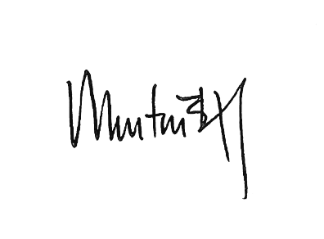

Yours sincerely,

Morten Bødskov

